Platform 4
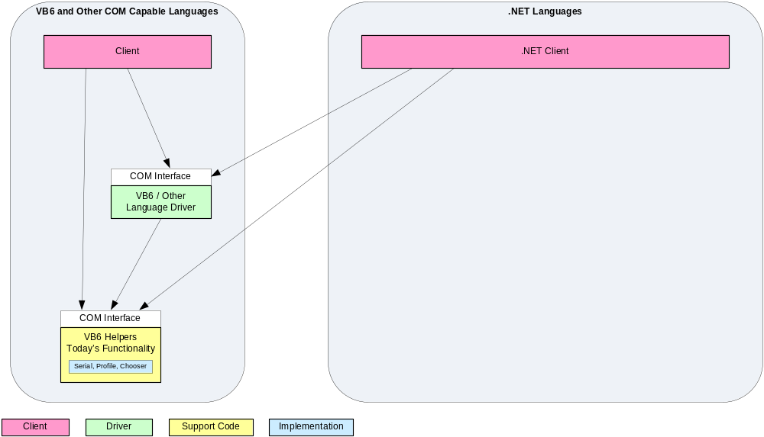

Platform 5
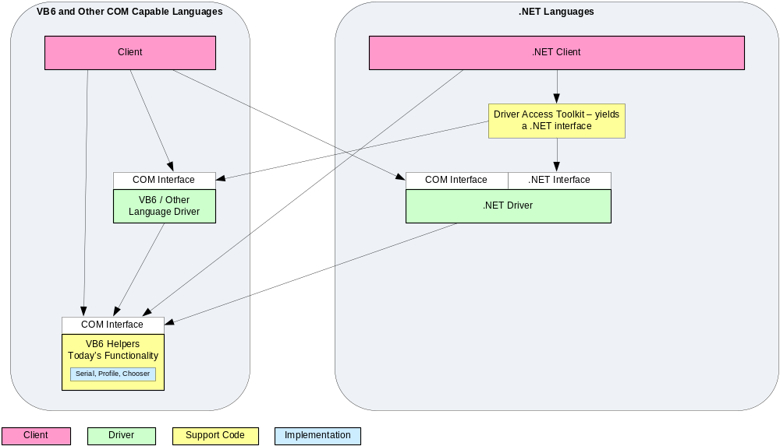

Platform 6* - Original COM Clients
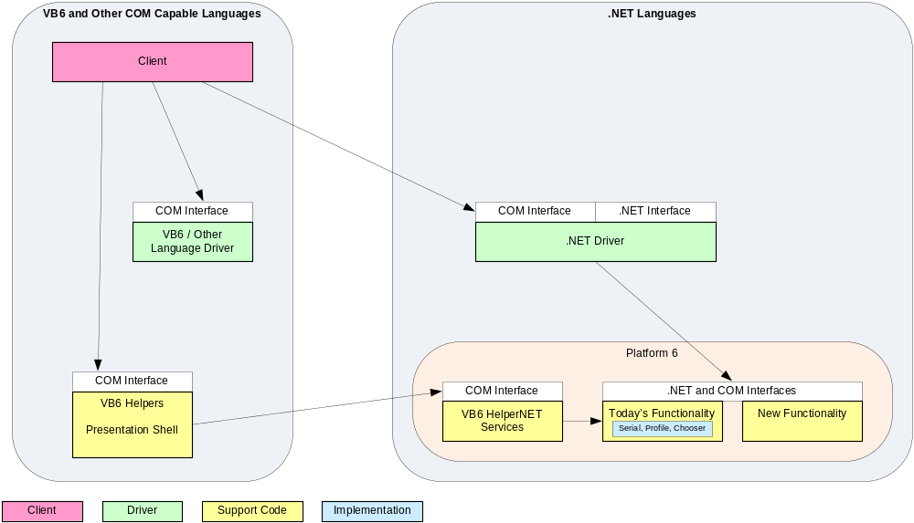
* Also Platform 5.5
Platform 6* - New COM Clients
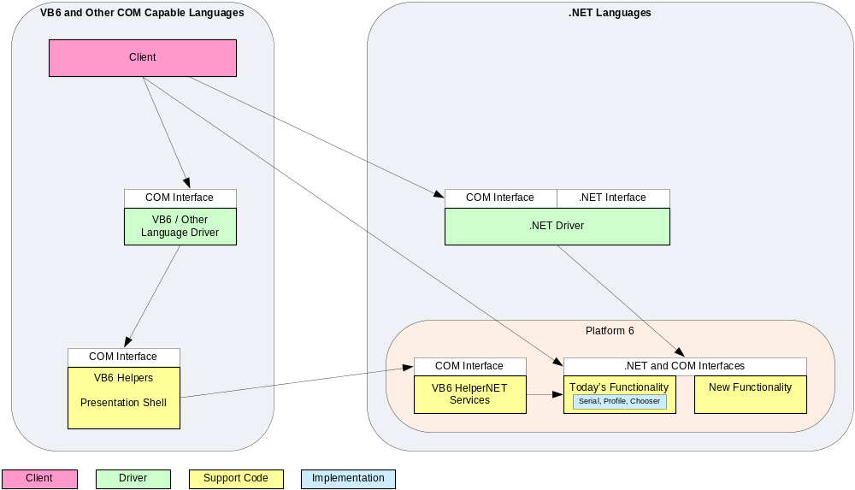
* Also Platform 5.5
* Also Platform 5.5

Platform 6* - New COM Drivers
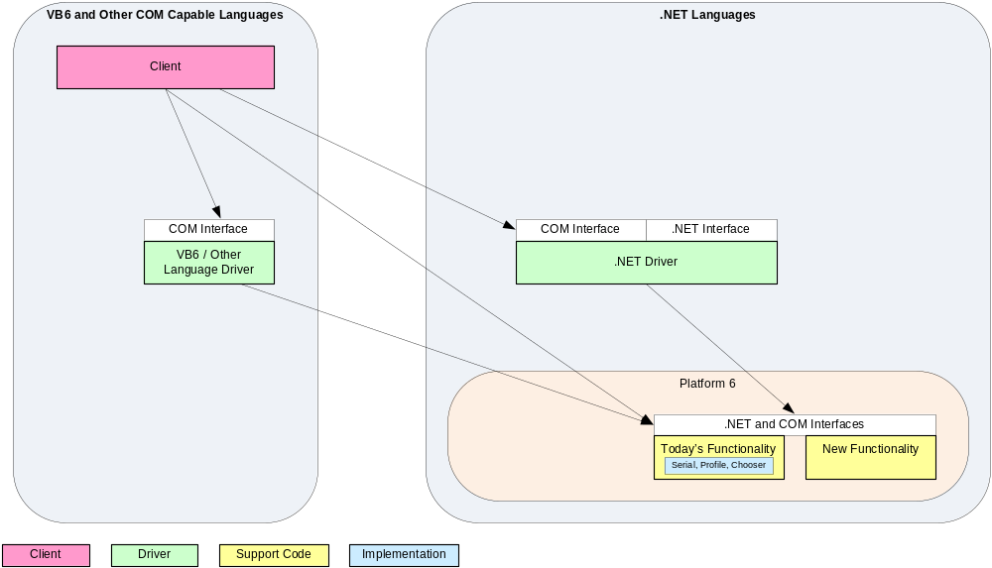
* Also Platform 5.5
* Also Platform 5.5

Platform 6* - .NET Clients
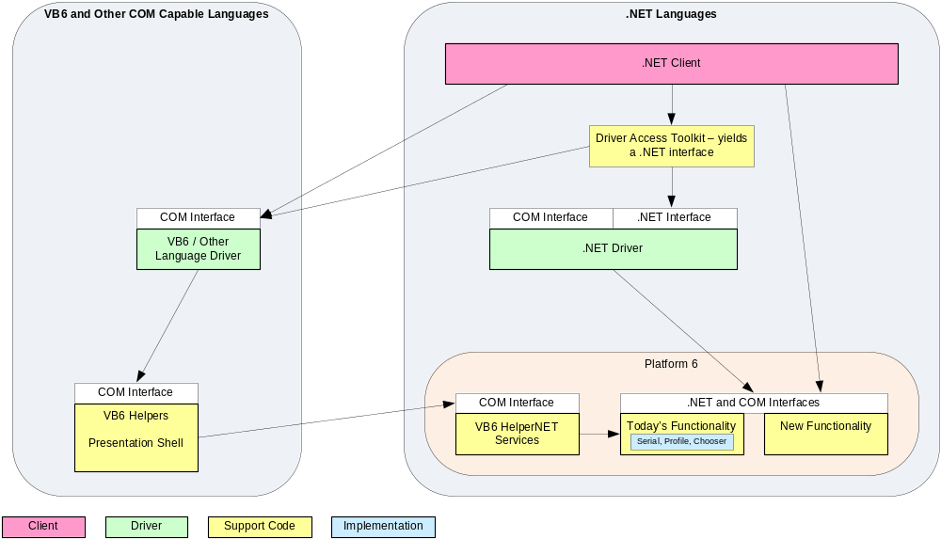
* Also Platform 5.5

